Seminar Gazette

Created by Seminar Gazette editors- Anna Smith, Natalie Cottrell and Teagan Mortenson | January 2017

“Houston, this is Seminar and we have incredible mission briefs to share”. What an amazing job the seminar students did with their scripts and delivery of their research. They worked so hard and the videos were simply WOWZA!!!!!!! Enjoy some stills from their projects.  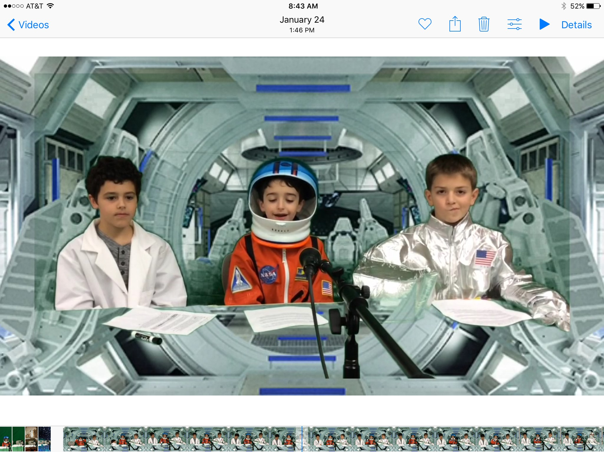  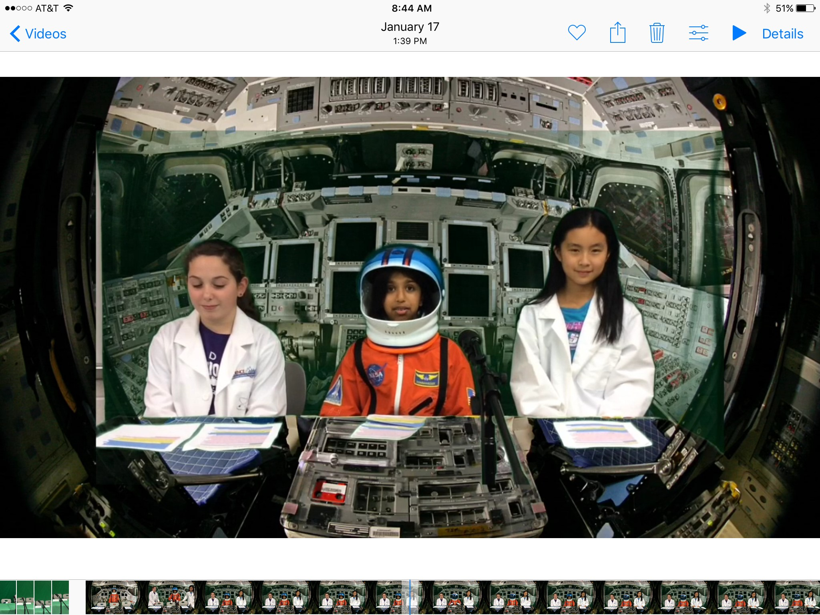 | 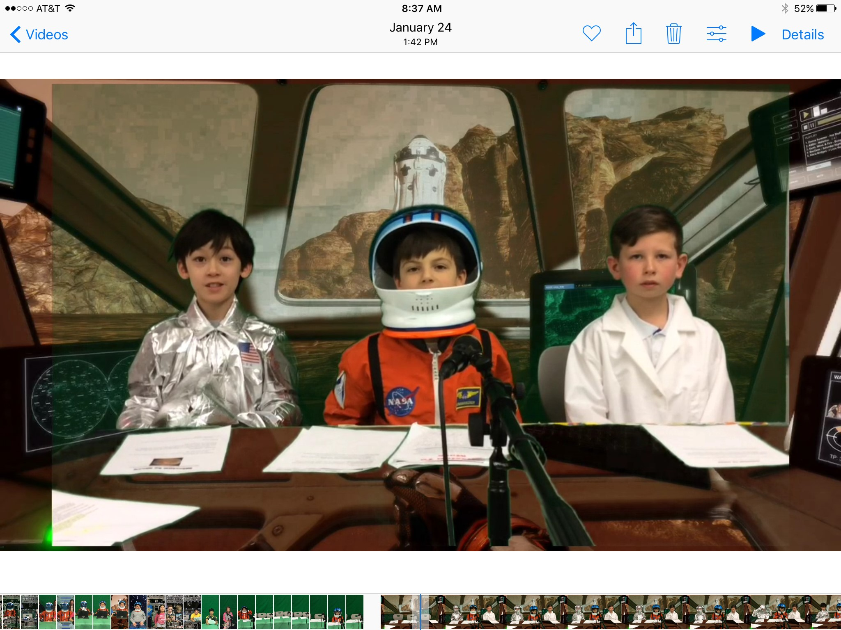 | 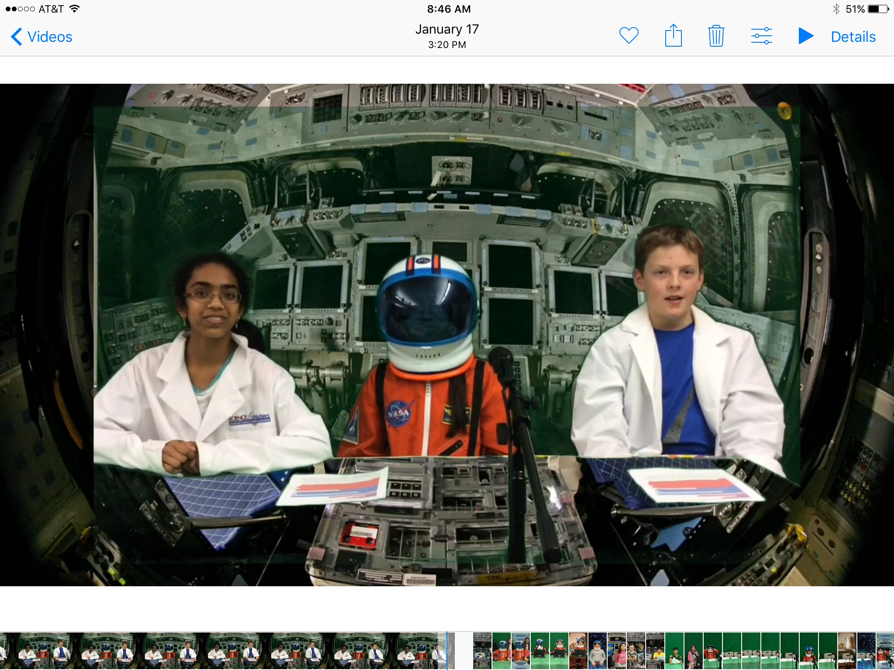  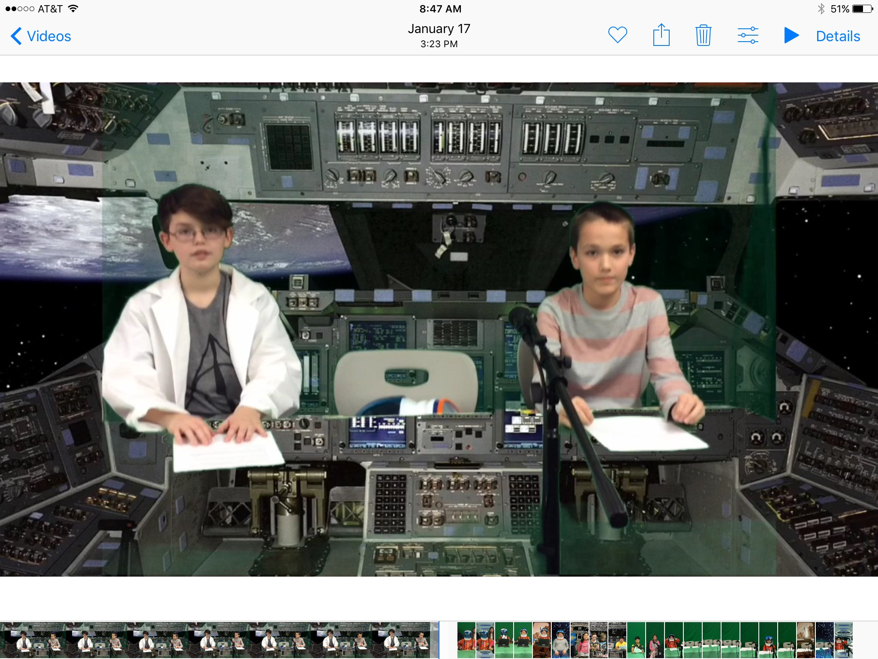  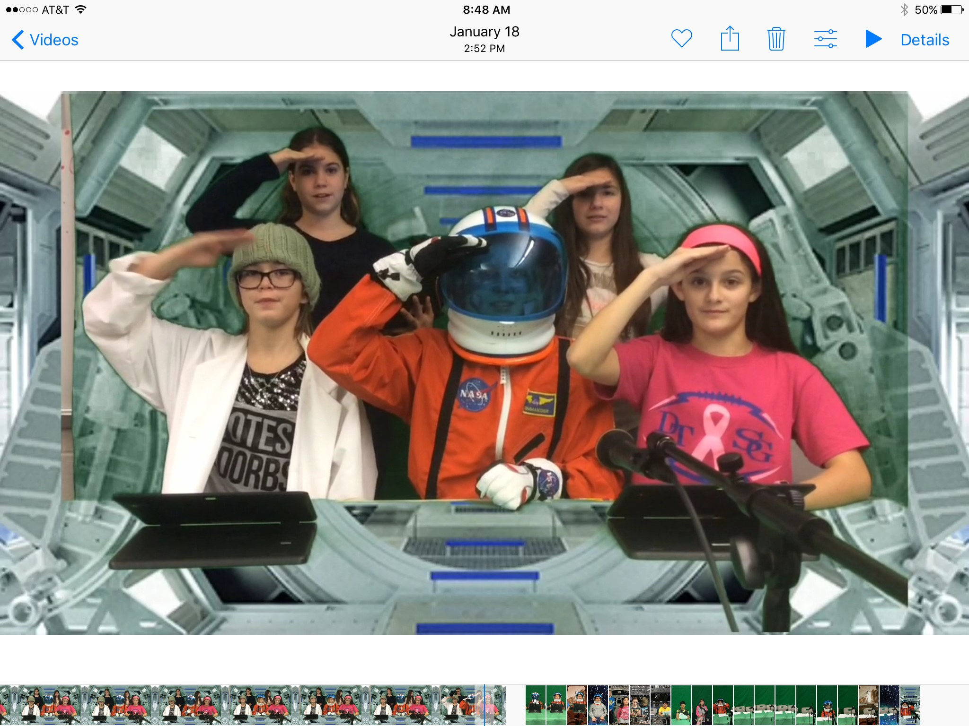

Page 1 | Continued on Next Page

MARS BRIEFS CONTINUED….
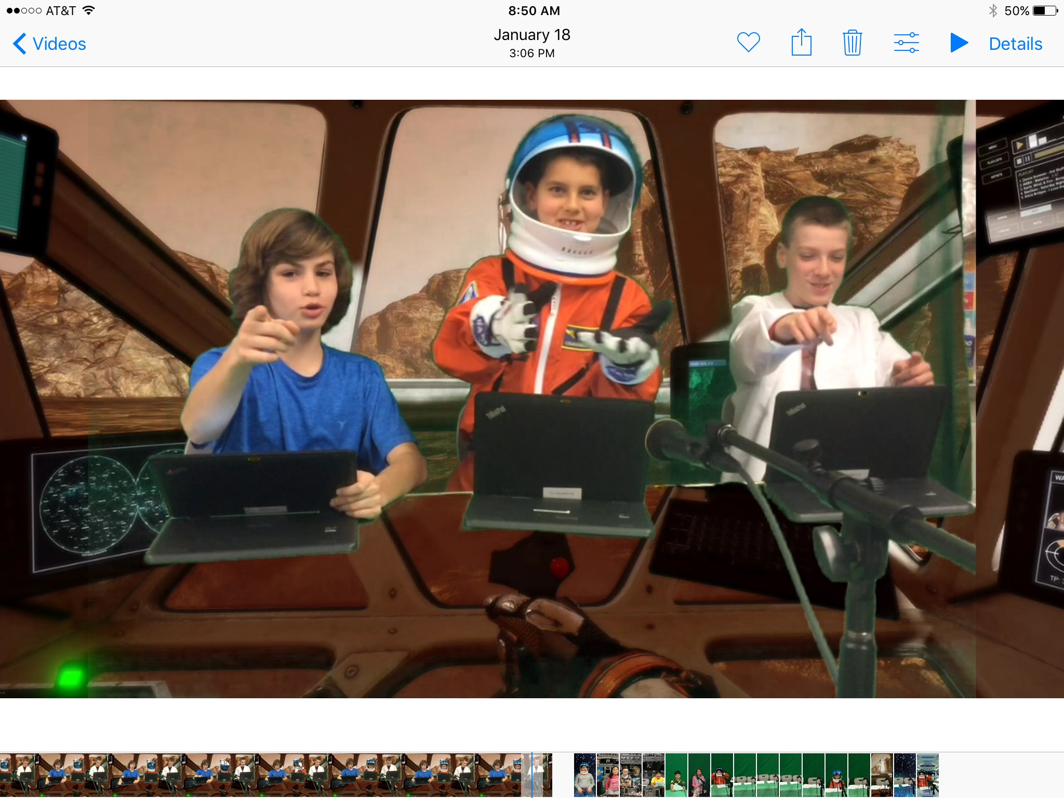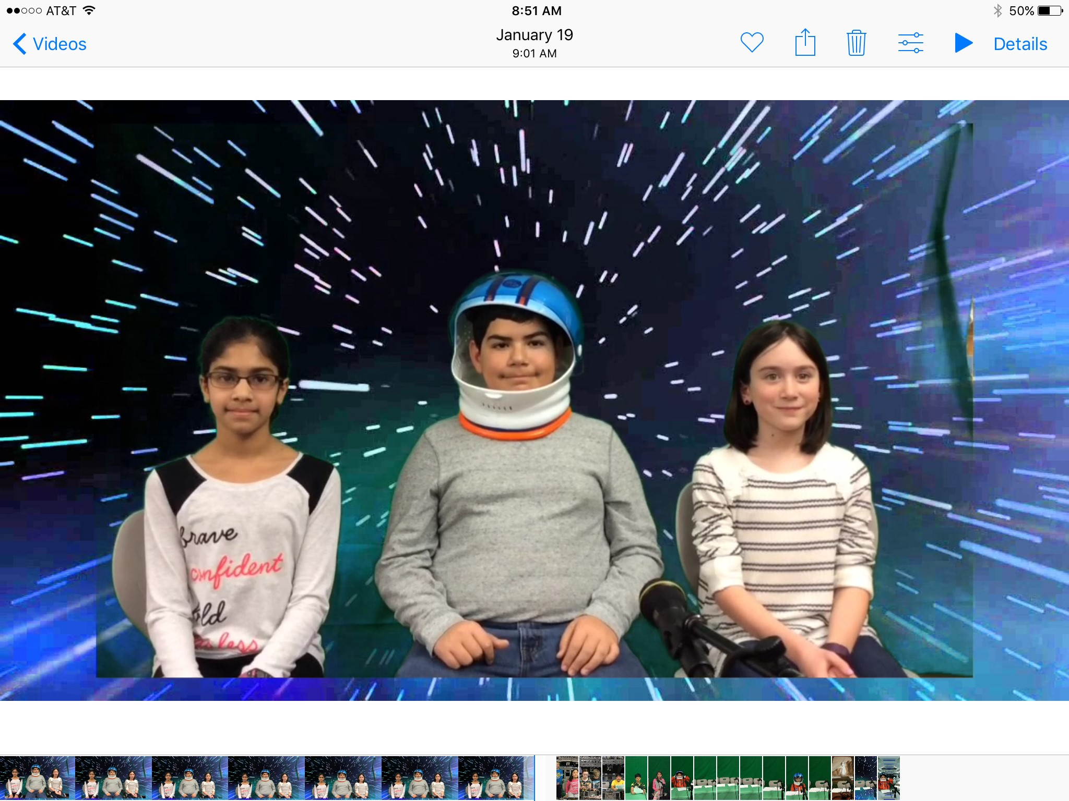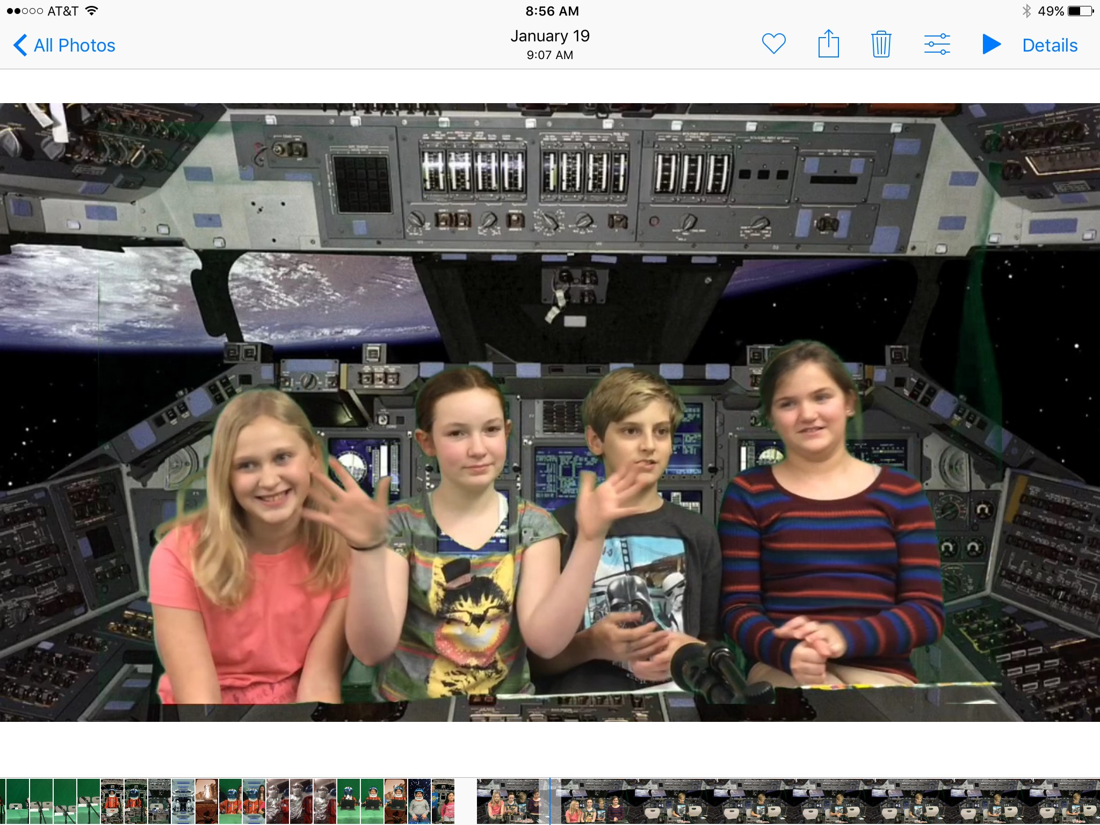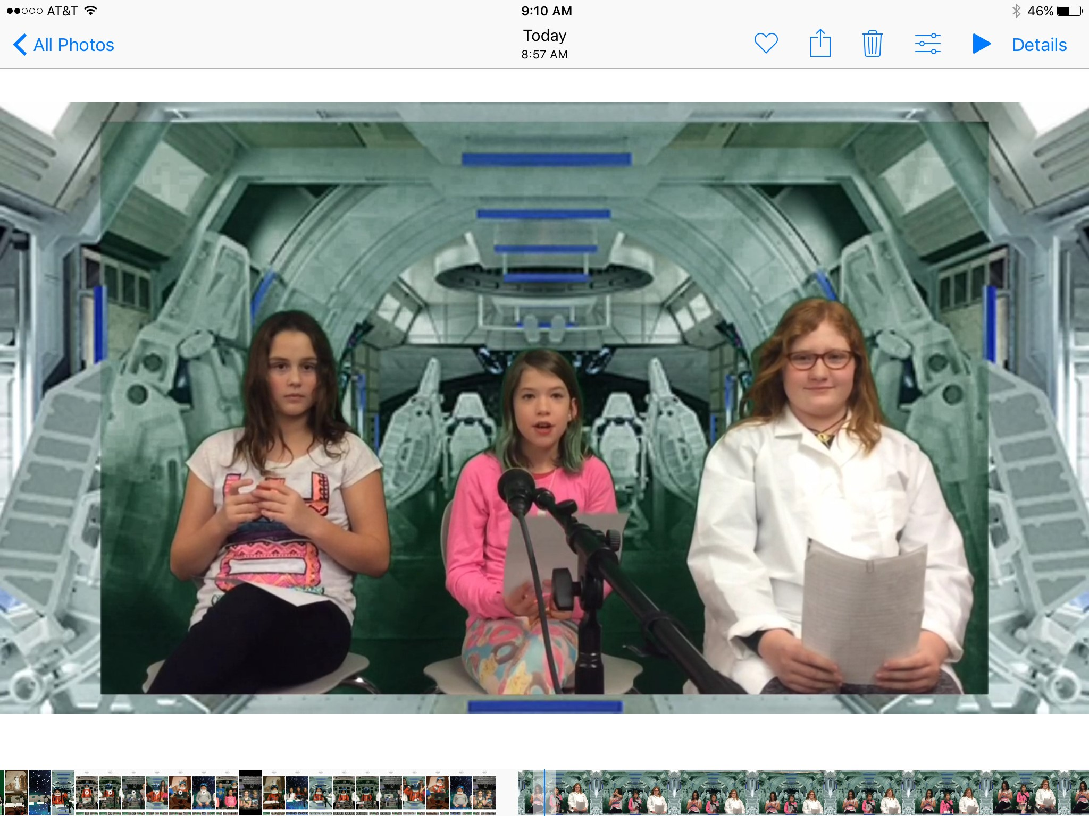

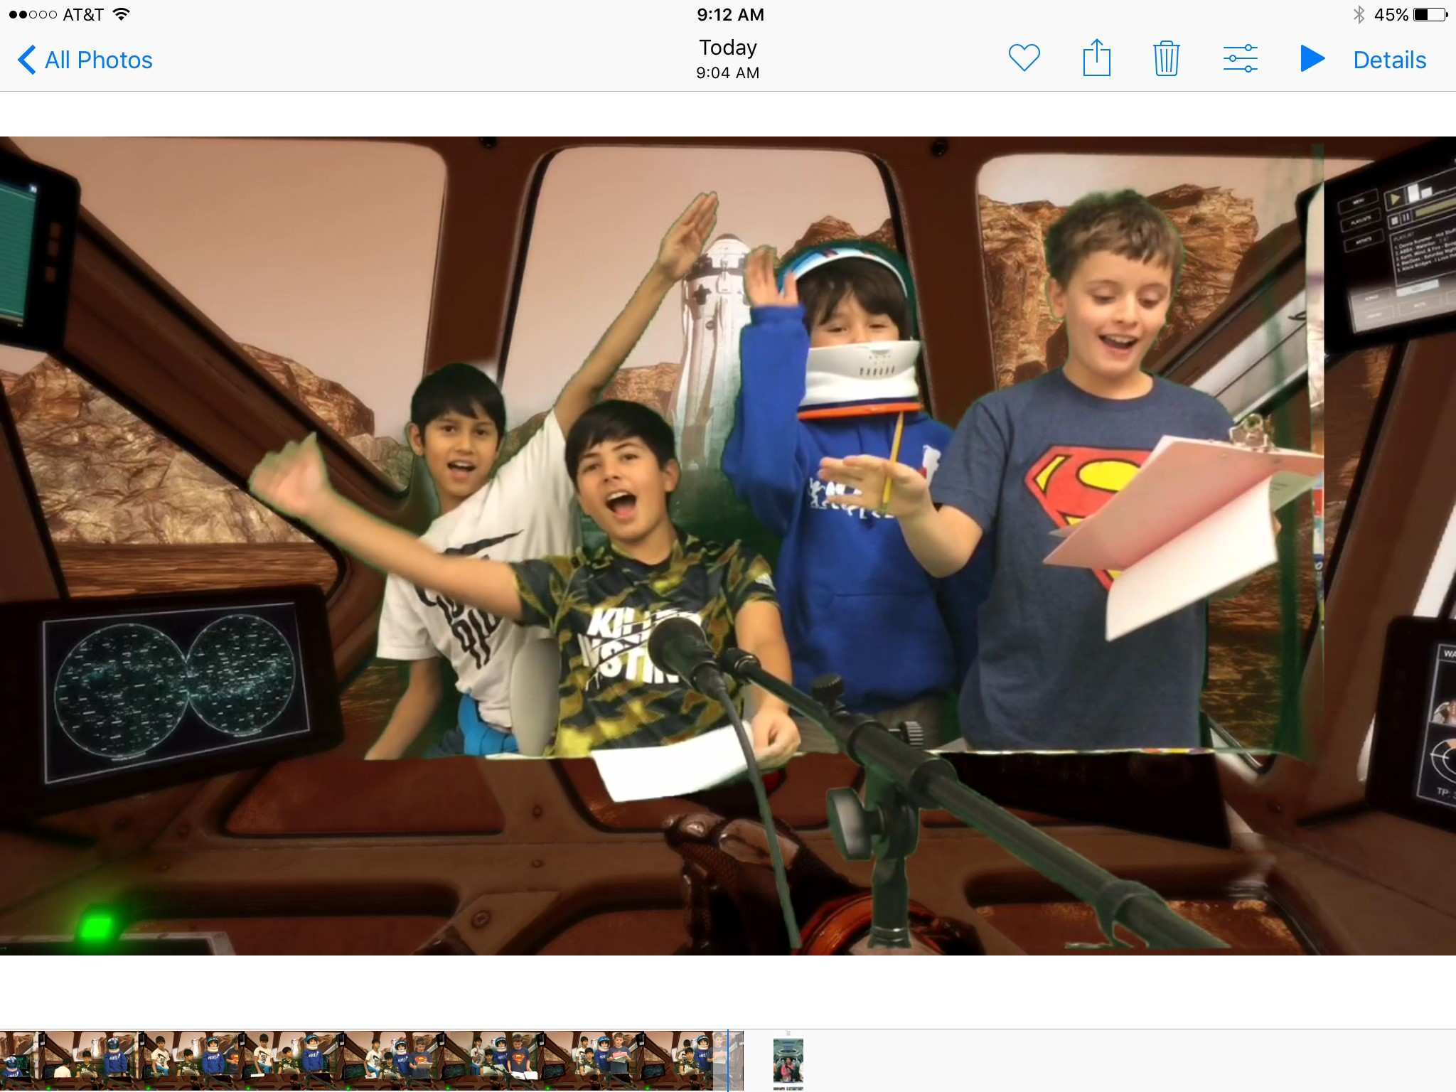

Greetings,

As you can see, the seminar students have been hard at work. Our next adventure involves applying some of their knowledge to thinking about what life on Mars is really going encompass. Students are being given the opportunity to share their perception of living on a community on Mars. Students may work alone or with a partner. What will living on Mars be like, feel like or look like? Get ready to find out. Students can write a book, design a comic, create living dwellings, design posters, design blueprints, and create digital representations, design transportation vehicles and more. This is going to amazing to watch as the creativity unfolds. Stay tuned.

In addition to our Mars communities, we are going to debating some popular conspiracy theories. So many of our history mysteries are wrapped in fact or fiction, what do you believe. After the presentation of data from both sides of the event, students will form an opinion and then debate their stance. First conspiracy theory: The July 1969 Moon Landing. Did the Eagle really land on the moon or was it a film set? We will let you know our findings in the next edition.
Miss Mars

Quotes that students wanted to share:
- “Be yourself. People don't have to like you and you don't have to care.” Anonymous
- “Love life the way it is.” Anonymous
- “Be yourself, everyone else is taken.” Oscar Wilde
- “The wand is only as good as the wizard.” - Dr. Albus Dumbledore

“If you can't fly then run, if you can't run then walk, if you can't walk then crawl, but whatever you do you have to keep moving forward.”
Dr. Martin Luther King Jr.

HODGE PODGE
